|  |
| --- |
| Safety Data Package  Dossier de soumission S&AM |
| Payload Name :  **High Altitude Balloon (HAB) Microbial Aerosols Sampling**  **Centre for Planetary Sciences and Exploration (CPSX) - Western University**  As part of  Canadian Stratospheric Balloon Experiment Design Challenge (CAN-SBX) led by Students for the Exploration and Development of Space (SEDS Canada) |
| Strato-Science 2019 Campaign  Phase 3 |
| Revision : 4 |
| Date  2019-07-17 |

**CSA-STRATOS-DP-0050**

Page intentionally left blank

Page libre intentionnellement

APPROVAL / Approbation

|  |  |  |  |
| --- | --- | --- | --- |
| Prepared by / Préparé par: |  |  | 2019-07-17 |
|  | Matthew Svensson  Principal Investigator  Western University |  | Date |
| Prepared by / Préparé par: |  |  | 2019-07-17 |
|  | Alexis Pascual  Co-Investigator  Western University |  | Date |
| Prepared by / Préparé par: |  |  | 2019-07-17 |
|  | Mohammad Chamma  Co-Investigator  Western University |  | Date |
| Revised by / Révisé par: |  |  | 2019-07-19 |
|  | Philippe Vincent  Engineer, Mechanical  Canadian Space Agency |  | Date |
| Revised by / Révisé par: |  |  | 19-07-2019 |
|  | Mouhannad Nassouri  Engineer, Safety and Mission Assurance  Canadian Space Agency |  | Date |

RECORD OF REVISIONS / Historique de révision

| Rev. | Description | Approbation | Date |
| --- | --- | --- | --- |
| IR | Phase 1 – Initial release | MS | 2019-03-22 |
| 2 | Phase 2 | MS | 2019-06-06 |
| 3 | Phase 3 – wrong template | MS | 2019-07-17 |
| 4 | Phase 3 – template modification | PV | 2019-07-19 |
|  |  |  |  |

TABLE OF CONTENTS / Table des matières

1 Introduction 9

1.1 PURPOSE / objet 9

2 Documents 10

2.1 Documents 10

3 List of Abbreviations 11

4 Technical Description 12

4.1 Mission Objectives 12

4.1.1 Description 12

4.2 Components Description and Function 13

4.2.1 Center of Mass 18

4.3 Mounting Interface 20

4.4 Design of Mechanical Components 21

4.4.1 Load cases 21

4.4.2 Design Loads and Safety Factors 21

4.4.3 Validation method 21

4.4.4 Robustness of attachment points 22

4.4.4.1 Margin of Safety 22

5 Thermal ANALYSIS 25

5.1 Thermal Environment 25

5.2 Thermal Protection 25

5.2.1 Thermal control system 25

6 Electrical 27

6.1 Power Consumption 27

6.2 Power Source 28

6.2.1 Batteries 28

6.2.2 Other source 28

6.2.3 Electrical protection 28

6.2.4 Electrical cables 28

6.3 Interconnection Diagram 29

6.4 Grounding 29

6.5 Telemetry 30

7 EMI/EMC CHARACTERISTICS 31

7.1 Magnetic Properties 31

7.1.1 Magnetic Field 31

7.2 RF Susceptibility and Compatibility 31

8 Handling Requirements 32

8.1 Handling 32

8.2 Cleanliness (contamination) 32

9 CERTIFICATION requirements 33

10 Recovery Procedure 34

11 RISK MITIGATION 35

11.1 S&MA requirements 35

11.1.1 Application to PLG and PL 35

11.1.2 RISK IDENTIFICATION AND MITIGATION 35

11.1.2.1 Control of fault propagation from the PLG to the aerostat 35

11.1.2.2 Robustness of mechanical elements connecting the PLG to the flight train 36

11.1.2.3 Safety analysis 36

11.1.2.4 Mitigating risks related to jettisoning elements 36

Appendix A 38

A.1 RISK ANALYSIS 39

A.2 HAZARD Summary 42

Appendix B 43

B.1 compliance MATRIX for PLG and payload on board of ZPB 44

Appendix C 59

C.1 COMPLIANCE STATEMENT REFERENCES 60

C.1.1 MECHANICAL ANALYSIS 60

C.1.2 TESTS 60

Appendix D 61

D.1 THORLABS GC25075-RB - Rubidium Borosilicate Reference Cell 62

Appendix E 63

E.1 RECOVERY PROCEDURE 64

List of figures / Liste des Figures

Figure 4‑1: Laser diode package (left) and laser control board and mount (right). 13

Figure 4‑2: Schematic of a physics package (inclusive to the dashed line) with control and data storage electronics. The components in the grey box are not included in the flight configuration 14

Figure 4‑3: Storm iM2275 Pelican case showing the main mounting breadboard and its position at the base of the case. All optical components lie on the breadboard. Electronics are stowed in board-mount boxes within the lid of the case. 17

Figure 4‑4: Configuration of SORCE showing two physics packages. The white boxes indicate the position of photodiodes which utilize batteries for power. 18

Figure 4‑5: SORCE payload with electronics mounted at the top of the Pelican case. This is accomplished via an aluminum plate bolted to the top lid of the case. All components are either screwed into the plate, or strapped with Velcro straps. 18

Figure 4‑6: Configuration of SORCE components on breadboard with Center of Mass marked on the left. 19

Figure 4‑7: The Storm iM2275 Pelican case features recessed sections where straps (here in orange) secure the payload to the gondola. *Credit: AlbertaSat* 20

Figure 4‑8: Applied loads and constraints for mechanical strain/stress analysis. Results are shown in Figure 4‑10. 22

Figure 4‑9: Two analyses were performed on the cell and cell mount. The resulting overall displacements of the aluminum plate were 0.00003 in and 0.00005 in for 6.94 g and 10 g, respectively. The displacements are exaggerated in the pictures. These displacements are both less than 1 thou, are not greater than 1 layer of Kapton tape, and therefore do not result in any deflection of the glass cell. The safety factor is above 11 everywhere for each case. 23

Figure 4‑10: Mechanical strain/stress analysis (safety factor and displacements in each axis) for all four load levels. 24

Figure 5‑1: Preliminary flight profile of the LIFE gondola. 25

Figure 6‑1: Configuration of the electronics plate stored within the lid of the Pelican case. Parts are color coded by DC-DC converter supply. 28

Figure 6‑2: Current interconnection diagram for the SORCE payload. 29

List of tables / Liste des Tables

Table 1‑1 : Summary of Phases S&MA 9

Table 2‑1 : Documents applicables et de référence 10

Table 3‑1 : List of abbreviations 11

Table 4‑1: Objectives of the SORCE experiment including primary and secondary success criteria. 12

Table 4‑2: H10721-110 photosensor module specifications. 14

Table 4‑3: BME280 environmental sensor specifications. 16

Table 4‑4: Mass budget for SORCE with margins. The second column is indicative of the status of the mass estimate; E = estimated mass, M0 = calculated using a 3D solid model, M1 = taken from a manufacturer spec sheet, M2 = measured using a scale. 16

Table 4‑5: CARMENCITA mass and limit loads. 21

Table 4‑6 : Summary of Safety Margins 23

Table 5‑1: Summary of operating temperatures for various components. 26

Table 6‑1: Power consumption of various components on SORCE during three different operational modes. Power consumption estimates do not include DC/DC converter efficiencies. 27

Table 7‑1: Frequency summary. 31

Table 10‑1: Hazard summary. 42

# Introduction

## PURPOSE / objet

*This document contains the safety related data for the integration of a payload (or a payload gondola) dedicated to fly on board a CNES BSO (ZPB) aerostat. This certification package meets the safety requirements for the integration of Canadian payloads on board the aerostat, according to the CNES user manual (AD4).*

*The Safety Data Package of a payload (or a payload gondola) includes:*

1. *The completed technical questionnaire (DA3)*
2. *The mechanical and electrical justifications*
3. *The present document, through three phases (Table 1‑1):*

*Phase 1*

* *Fill out this document by providing a preliminary design with foreseen steps (Pictures of the payload components in a lab environment or CAD model screenshots can be use).*
* *Also fill appendix B without providing justifications (only your compliance intention to the requirements)*

*Phase 2*

*Update preliminary design, by providing the detailed design (if applicable)*

*Update appendix B and provide all mechanical and electronic justifications (analysis, calculations, test report, etc.)*

*Phase 3*

* *Update, answer to CSA comments and provide final version of the Safety Data Package.*

*The safety Data Package will be reviewed and approved by the CSA through a Formal Technical Review before the campaign. And a compliance certificate issued by S&MA representative at the launching base.*

*The document can be completed in French or English*

Table 1‑1 : Summary of Phases S&MA

|  |  |
| --- | --- |
| **Phase** | **Description** |
| 1 | Conception |
| 2 | Production |
| 3 | Implementation |
| Compliance matrix | Integration |

# Documents

## Documents

*The following documents are identified as applicable (AD) or reference (RD) documents.*

*Applicable documents are an integral part of this document and reference documents provide*

*additional information or guidelines that can clarify the content of this document or that are*

*relevant to its history.*

Table 2‑1 : Documents applicables et de référence

|  |  |  |  |  |  |  |
| --- | --- | --- | --- | --- | --- | --- |
| **No.** | **Doc. No. / Numéro de document** | **Document Title / Titre du document** | **Ver/ Rév.** | **Date** | **AD / DA** | **RD / DR** |
| 1 | **CSA-STRATOS-PR-0004** | Procédure de soumission d’un dossier de S&AM pour une Charge Utile ou une Nacelle de charge(s) utile(s) canadienne(s) | B |  | √ |  |
| 2 | **CSA-STRATOS-RPT-0004** | Règlement de sauvegarde de l’ASC pour les opérations d’aérostats | B |  |  | √ |
| 3 | **CSA-STRATOS-FORM-0004** | STRATOSPHERIC BALLOON PAYLOAD INTEGRATION TECHNICAL QUESTIONNAIRE  /  QUESTIONNAIRE TECHNIQUE D’INTÉGRATION D’UNE CHARGE UTILE À UN BALLON STRATOSPHÉRIQUE | C |  | √ |  |
| 4 | **BSO-MU-0-4793-CN-VA**  **/**  **BSO-MU-0-4793-CN** | USER MANUAL FOR CNES ZERO PRESSURE BALLOONS  /  MANUEL UTILISATEUR  POUR LES BALLONS STRATOSPHERIQUES OUVERTS DU CNES | 3.0 | 19 jan 2018 | √ |  |

# List of Abbreviations

Table 3‑1 : List of abbreviations

|  |  |
| --- | --- |
| Abbreviation | Definition |
| **ASC** | Agence Spatiale Canadienne |
| **BSO** | Ballon Stratosphérique Ouvert (Zero-Pressure Balloon) |
| **C&DH** | Command and Data Handling |
| **CAO** | Conception assistée par ordinateur |
| **CNES** | Centre National d’Études Spatiales (French Space Agency) |
| **CPU** | Central Processing Unit |
| **CSA** | Canadian Space Agency |
| **CU** | Charge utile |
| **DBR** | Distributed Bragg reflector |
| **EMC** | ElectroMagnetic compatibility / Compatibilité électromagnétique |
| **EMI** | ElectroMagnetic Interferences / Interférence électromagnétique |
| **ESD** | ElectroStatic Discharge |
| **MDE** | Module de distribution d’énergie |
| **MALT** | Mise à la terre |
| **NCU** | Nacelle Charge Utile |
| **NSO** | Nacelle de Servitude Opérationnelle |
| **NMT** | Niveau de maturité technologique |
| **OAC** | Optical Atomic Clock |
| **OBC** | On Board Computer |
| **PI** | Principal Investigator (scientifique principal) |
| **PLG** | Payload Gondola |
| **PMT** | Photomultiplier Tube |
| **RFI** | Radio Frequency Interferences |
| **SORCE** | Stratospheric Optical Rubidium Clock Experiment |
| **S&AM** | Sécurité et Assurance de Mission |
| **S&MA** | Security and Mission Assurance |
| **TEC** | Thermoelectric Cooler |
| **ZPB** | Zero-Pressure Balloons |

# Technical Description

## Mission Objectives

The Microbial Aerosols Sampling instrument is a

Payload: Yes X No □

Payload Gondola: Yes □ No X

### Description

The goal of the Centre for Planetary Science and Exploration’s (CPSX) High-Altitude Balloon (HAB) initiative is to sample bioaerosols along a vertical transect through the atmosphere. Bioaerosols in the upper atmosphere are poorly studied and comprise a significant gap in the scientific literature. The present study assesses whether the inaccessibility of the upper troposphere and atmosphere can be circumvented using a stratospheric balloon platform. This research will provide additional resources for studying the distribution and character of bioaerosols vertically through the atmosphere and would comprise the first study detailing the utility of stratospheric balloons as a platform with which to study them.

This document includes detailed descriptions of the sample chamber design, the experimental design and associated procedures, a listing of all equipment necessary for payload construction, the thermal plan for managing temperature within the payload, a requirements matrix, and a description of the testing procedures. In addition, we include updated timelines and task allocations for each team member, as well as an updated budget.

The sampling system will be modified from Bryan et al. (2014) in order to better integrate with the Stratos gondola and to accommodate a higher sampling resolution. Each chamber designed to sample microbial aerosols will hold 20 Rotorods ® each with a surface designed to sample via impaction. Our suggested design involves an aluminum chamber with a drawer mechanism driven by a linear actuator and sealed by a piston seal o-ring and a face seal o-ring. The main flight computer is an Arduino Mega 2560, with add-ons for data logging, ethernet port interface, and a GPS module. Cameras mounted inside the Pelican case provides visual confirmation of the opening and closing of the chambers. Cerafelt blankets will be used as insulation to mission critical components.

The project timeline can be broken down into five main phases: (1) logistics and design, (2) assembly and testing (3) dedicated testing (4) flight and sample collection (5) data analysis and interpretation. Each phase has its own internal timeline for completion. **Phase 1:** January - March. **Phase 2:** March - July. **Phase 3:** June - August. **Phase 4:** August Phase 5: September and onward.

Our team has a total projected cost of $6505.45 CAD with approximately 68% allotted for payload design, construction, and testing. In addition, 32% of the total projected costs is alloted for travel and flight day logistics. With a 15% margin we are above the guaranteed amount of funding available from CPSX ($5000). We are developing a sponsorship package to acquire additional funding from sources outside the CSA and Western.

Through the Centre of Planetary Science and Exploration (CPSX), the team has multiple avenues for outreach including Space Day presentations, high school Seminars and the Summer Space Explorers Camp. The significance and merit of High Altitude Balloon projects will be discussed during these events in order to generate interest in space among youth groups.

## Components Description and Function

The payload will be occupied primarily by 5 sampling chambers, 4 linear actuators that will serve to open and close the chambers, and an Arduino MEGA 2560 serving as the flight computer. The figure below shows the planned payload layout as well as drawings of a single sample chamber. The dimensions of the sample chamber will be 55mm x 45mm.

|  |
| --- |
| **Payload Layout:**  **Sample Chamber:** |

Figure 4‑1 : Payload or PLG Picture / image de la charge utile ou NCU

Table 4‑1 : Mass budget (KG)

|  |  |
| --- | --- |
| Instrument | **2.9** |
| Pelican case | **4.0** |
| Hardware (brackets x4 + straps x2) | **0.5** |
| cables | **0.6** |
| margin | **1.0** |
| Total | **9.0** |

### Center of Mass

Center of mass location is considered being in the middle of the row of sample chambers, referenced from the back-left corner of the Pelican case, nearest to the sample chambers (see Figure 42). With the back-left corner considered (0, 0, 0), and the X, Y, and Z dimensions of the case being 33.50cm, 35.90cm, and 25.10cm respectively, the coordinates of the COM are approximately at:

X = 15.71 cm (± 2 cm)

Y= 7.34 cm (± 2 cm)

Z= 2.00 cm (± 2 cm)

The majority of the weight of the payload is from the weight of the sample chambers.

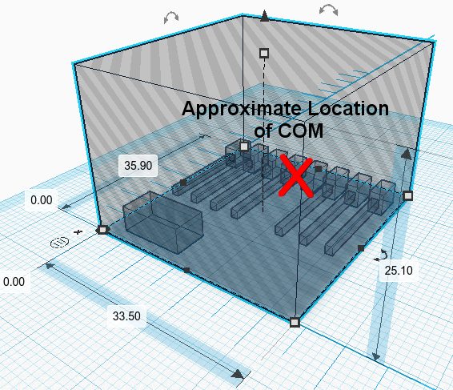

Figure 4‑2: Payload Center of Mass

## MOUNTING INTERFACE / INTERFACE DE MONTAGE

The payload will be housed inside the pelican case provided by SEDS, which must be mounted to the gondola such that the vents on either side of the pelican case are not obstructed and allow air to enter it. As of now, the CPSX-HAB team does not know what other experiments will be in the immediate vicinity of the payload or what the expected proximity to these experiments will be. The CPSX-HAB payload will required both vents on opposing sides of the pelican case to be exposed to the outside atmosphere. The exact required clearance to enable sufficient airflow through the pelican case is not known at this time but it is expected to be at least 10–15 cm.

The Storm iM2275 Pelican case will be secured using two (2) straps and four (4) L-brackets with M6 screws provided by the CNES/CSA (see Figure 4‑3). Detailed calculation are shown in Appendix C.1.1

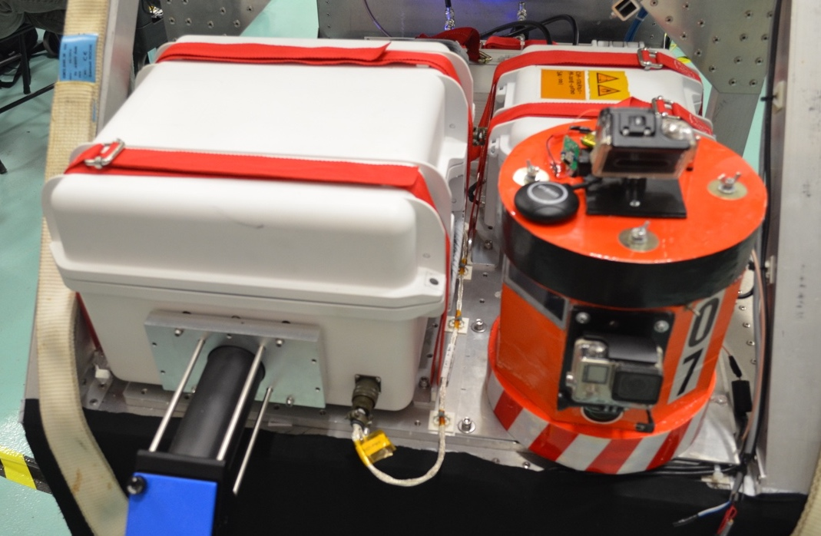

Figure 4‑3: CAN-SBX 2018 MIIST payload (left) secured to the gondola using straps (here in red).

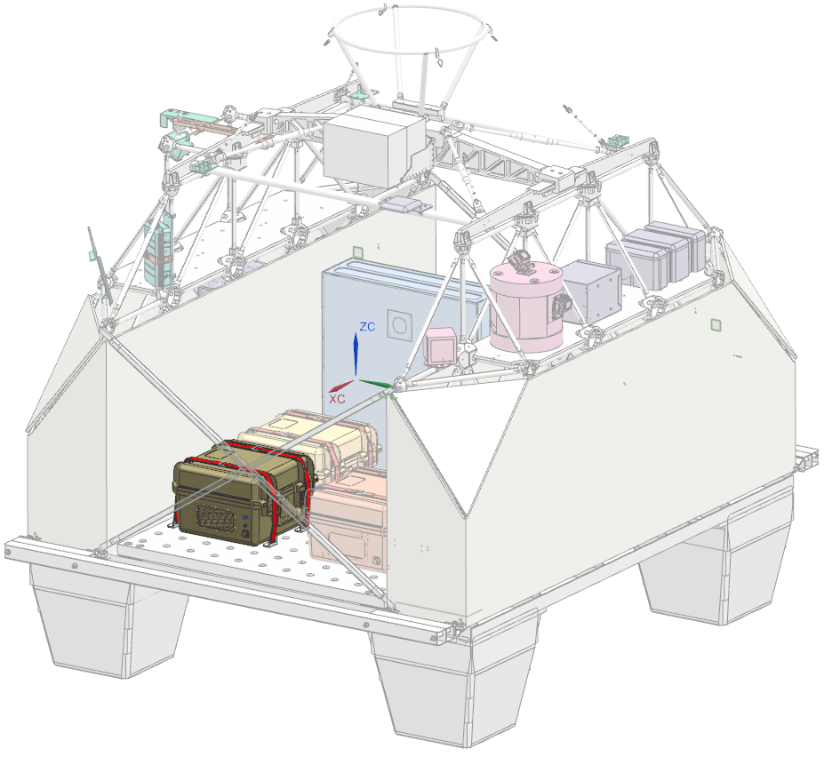

Figure 4‑4 : HAB Microbial Aerosols Sampling instrument location on CARMENCITA LIFE 2019 Gondola

## DESIGN OF MECHANICAL COMPONENTS / CONCEPTION DES COMPOSANTS MÉCANIQUES

### Load cases

The payload components must withstand the combined limit loads (LL) generated in the design cases explained in AD4 and summarized here.

Table 4‑5: CARMENCITA mass and limit loads.

|  |  |  |  |
| --- | --- | --- | --- |
| Payload gondola | Gondola Total mass* | Maximum acceleration in Z‐axis on the payload gondola | Transverse acceleration X-Y on the payload gondola |
| CARMENCITA | 600 | 6.8 g | 1.4 g |

*Information provided by the CSA

The combined acceleration to consider is therefore the following:

|  |  |
| --- | --- |
| AC = **= 6.94 g** | [Equation 1] |

### Design Loads and Safety Factors

The Limit Load (LL) are calculated based on the acceleration shown in Section 4.4.1 above and the payload total mass (mT) of 9 kg declared in Table 4‑1.

*The safety factors to consider are explained in AD-4 and summarized here :*

*- project coefficient (KP) = 1.15*

*- model coefficient (KM) = 1.4*

*- yield design factor of safety (FOSY) = 1.25*

*- ultimate design factor of safety (FOSU) = 1.5*

By definition:

|  |  |
| --- | --- |
| LL (limit load) = mT x AC x 9.81 | [Equation 2] |
|  |  |
| DLL (design limit load) = LL x KP x KM | [Equation 3] |
| DYL (design yield load) = DLL x FOSY | [Equation 4] |
| DUL (design ultimate load) = DLL x FOSU | [Equation 5] |
|  |  |

### Validation method

HAB Microbial Aerosols Sampling instrument’s resistance calculation to these load level are explained in details in Appendix C.1.1.

### Robustness of attachment points

#### Margin of Safety

The margins of safety must be positive

- MOSY (yield margin of safety) = (YL / DYL) -1

- MOSU (ultimate margin of safety) = (UL / DUL) -1

Where YL is the Material Yield Load, and UL is the Material Ultimate Load.

Calculations are included in Appendix C.1.1 and a summary of the Margin of safety is provided in the following table. The straps and brackets have been qualified and are provided by CNES/CSA.

Table 4‑6 : Summary of Safety Margins

|  |  |  |  |
| --- | --- | --- | --- |
| Component | Margin of safety | | Reference |
| MOSY | MOSU |
| CNES 25mm Straps | NA | 4.26 | Appendix C.1.1 |
| L-Brackets | 61.96 | 69.10 |
| M6 Screws** | 1.09 | 1.94 |

** The margin of safety presented in the summary table shows the worst case between tension, shear and bending.

# Thermal ANALYSIS

## Thermal Environment

The payload will experience an estimated temperature of -25°C for extended periods of time. However, conversations with engineers from CSA indicate that the gondola will be exposed to temperatures of -75°C for a 15-minute burst. Despite this, the payload will be designed with -25°C as the ambient temperature as this is the temperature that the gondola will be exposed the longest.

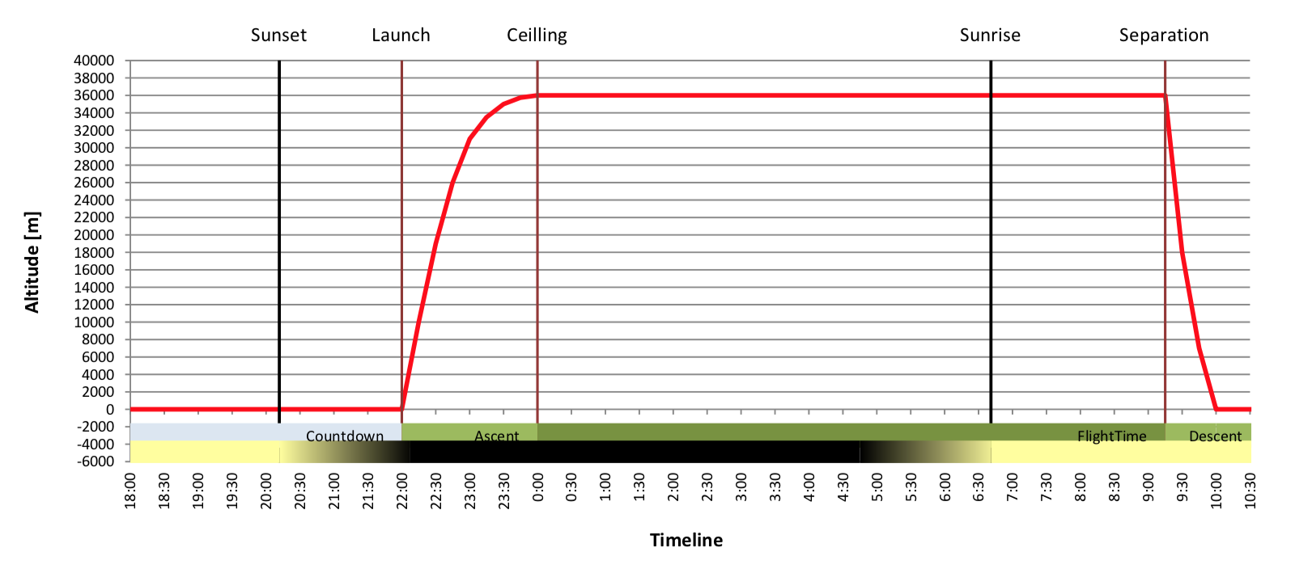

Figure 5‑1: Preliminary flight profile of the LIFE gondola.

## Thermal Protection

### Thermal control system

The 4 actuators will be placed within a 3D printed enclosure, which would then be walled with Cerafelt insulating foams. Each of the actuators will be wrapped with a resistive heater wrapped in Polyimide tape., which operates at 12V and 1.33A. The heating element will activate if an actuator is supposed to open at the current altitude *and* if the temperature inside the enclosure is too cold for it to operate. The temperature inside will be monitored by thermistors. Whenever the heater is turned on, it will only be active for about 30 seconds before it turns off.

To test the capabilities of the actuators with the heating elements and the designed enclosure, the freezer test will be repeated once all components have been made available. The actuators will be once again placed inside a -25°C freezer for about 2 hours. The heaters will keep the temperature inside the enclosure above the minimum operating temperature of the actuators all throughout the experiment. Actuator position will be monitored and recorded. If the actuators can be confirmed to function after the 2 hours, we will be confident that they will function within the flight.

# Electrical

## Power Consumption

The payload is designed to be powered by a nominal 28 V battery source which is provided by the gondola itself.

The peak power consumption is calculated to be at 28.24W. This peak will only be reached if the actuators are moving and the heaters are active. The actuators and the heaters would only be active for 30 seconds at a time, and for the rest of the flight, the nominal consumption is about 5W. For an estimated 12-hour flight, the total energy consumption is calculated at 106.8Wh. The following table provides the details, for each component. A separate power budget document will be provided for a more detailed calculation of the energy and power consumption.

Table 6‑1: Power consumption

|  |  |  |
| --- | --- | --- |
| **Component /**  **Composant** | **Consumption / Consommation** | **Notes** |
| Arduino Mega 2560 | 1.00 |  |
| Linear Actuators (4) | 6.24 | 4 linear actuators will be on board the payload. The actuators will only be operational one at a time and only for 30 seconds each time. |
| GPS Module | 0.241 |  |
| Camera | 0.375 |  |
| BME 280 Environmental Sensor | 0.000119 |  |
| Ethernet Shield + SD Card Write | 0.766 |  |
| Heating Pad | 15.96 | 4 heaters will be on board the payload. They will only be operational for 30 seconds at a time and only when the actuators are scheduled to move. |
| Fan (4) | 3.7 |  |
| Thermistors | .0025 |  |
| TOTAL: | **28.24W** |  |

## Power Source

### Batteries

We will be using a 8 A line from the CSA Power Subsystem delivering unregulated 28 V (33.6 V to 24 V).

### Other source

None.

### Electrical protection

A 12V DCDC, 15A converter will be utilized to scale down the input voltage to the operational voltage of the flight computer and the linear actuators. The converter that will be used has a reverse voltage protection and it can handle 40V input.

### Electrical cables

Standard Arduino jumper cables will be used all throughout

## Interconnection Diagram

N/A

## Grounding

Grounding is done through the return wire that goes back to the CSA Power Subsystem.

## Telemetry

The payload will be connected to the PRISM subsystem, transmitting actuator position and environmental data inside the gondola. This allows us to monitor which chambers are on and at which stage of the flight. Pictures will not be transmitted.

HAB Microbial Aerosols Sampling instrument has been assigned the following static IP address: 172.20.4.240 with a TM bandwidth of 100 kbit/s

# EMI/EMC CHARACTERISTICS

## Magnetic Properties

### Magnetic Field

N/A

## RF Susceptibility and Compatibility

In its current state, the payload will not emit and is not susceptible to any of the bands used by CNES (see table below).

Table 7‑1: Frequency summary.

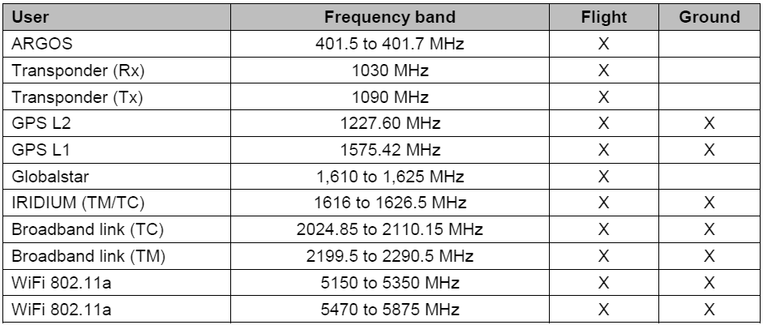

# Handling Requirements

## Handling

The attention of two to three individuals would be ideal to adequately prepare the payload for launch. The team will check the power connection to all on-board electronics, ensure the S.D. card is secured and check that the computer is logging the required data. The computer should be logging the GPS coordinates, temperature, pressure, ambient humidity, camera feed and actuator position. Additionally, the team will ensure actuator functionality by running an open-close sequence prior to loading the sampling rods. The team will also ensure the payload is structurally sound and ensure that the insulation pads are intact, free of any punctures or tears. The payload must then complete it’s open / close program to ensure all mechanical components are operating adequately.

## Cleanliness (contamination)

To ensure the sampling rods are not contaminated by the atmosphere during pre-flight activity, the rods are initially prepared and stored in a positive pressure clean lab. The positive air pressure in the lab prevents the contamination from airborne particles adhering to the rods when they are being loaded into banks of 20. A set of control rods (to be analyzed later) will be kept in the clean room to assess clean room’s base level contamination. A sample will also be collected from ground level at the flight location. This sample will not fly as part of the payload but will serve as a “sample 0” baseline when assessing for contamination.

The sampling rods are pre-loaded in banks of 20 and kept in a clean autoclave bag to minimize any biological contamination from ground-level atmosphere during transportation or loading. A small pinhole will be poked in the bag with an attached mesh to filter out any contaminants and ensure the bag can properly pressurize during ascent. All tools used to mount the sampling rods will be wiped with ethanol to clean them. On-site, the chambers themselves (without the doors, since they are in a sealed bag with the rotorods) will also be cleaned with ethanol prior to loading the bagged banks of sampling rods.

The vents on the sides of the chambers will be sealed by an adhesive wrapping to and locked to minimize the amount of possible contamination from water or mud upon landing. The sampling chambers are to be immediately placed in coolers filled with dry ice upon recovery (see Appendix E for the recovery procedure)

# CERTIFICATION requirements

CSA and CNES are responsible for certifying the PLG and specific instruments (e.g. payload). The certification analysis is carried out on the basis of the information provided by the PI for the purpose of demonstrating compliance with the requirements listed in Appendix A and B.

Compliance with the requirements must be demonstrated before the campaign and may require

technical discussions between CSA/CNES and the PI.

All the requirements listed in Appendix B concern PLGs developed by a scientific laboratory or

manufacturer. Among these, those applicable to instruments taken into account on CNES

gondolas are identified by an asterisk (*).

On site, the S&MA engineer verifies that the PLG (and its integrated elements) are fully compliant before the flight, particularly for the mechanical aspects. The PI is responsible for informing the S&MA engineer of any deviation from the Safety conformance file (Safety Data Package).

Expected compliance with compliance statements is presented in Appendix B .

# Recovery Procedure

The recovery procedure describes the steps required to passivate the payload and the associated hazards to ensure protection of the recovery crew. Please refer to Appendix D for the formatted recovery procedure document.

The CPSX-HAB payload does not include any material or device that is expected to be hazardous to the recovery crew. Given the vents on the side of the pelican case, the recovery crew should be wary of any debris that could cause laceration or puncture wounds that could have breached the pelican case. Additionally, any broken actuators, if present could be sharp. Once the payload’s power is cut from the gondola, any electrical hazards from exposed wiring due to impact related damage will be nullified. The recovery crew should refer to appendix and all upcoming iterations to properly and safely recover the payload.

# RISK MITIGATION

*This section highlights the requirements applicable to PLGs and PL/instruments carried on CNES’s ZPB aerostats. The purpose of these requirements is to demonstrate to CNES that PLG/PLs comply with safety regulations for balloon activities (see RD2, AD4 and RD5).*

*These requirements are applicable to all the instruments and gondolas that can be carried on a*

*CNES ZPB aerostat.*

## S&MA requirements

*Risk levels are defined in the safety regulations according to the following degrees of severity:*

***Catastrophic:*** *Loss of human life.*

***Serious****: Serious injury to people, significant damage to property or to the*

*environment.*

*Mitigating these risks requires the specification of qualitative safety requirements. No* ***single failure*** *(hardware failure, software error, human error...) shall involve a risk of*

*catastrophic consequences. For this reason, two safety barriers must be installed to counter catastrophic risks.*

### Application to PLG and PL

*As for any part of the aerostat, the PLG (PLs included) must not be subject to risks leading to catastrophic consequences following a single failure. The regulations concerning payload safety are expressed by the requirements listed in Appendix A and B of this document.*

*Thus, the PI must:*

* *ensure that PLG faults cannot propagate to the rest of the aerostat or, if this is not possible,*

*characterise these risks (electrical risks for the interfaces, etc.) to ensure that they are mitigated at the system level;*

* *ensure that the fastening point(s) at which the PLG and any other mechanical components*

*are attached to the flight train is/are sufficiently strong;*

* *ensure that the mountings of the instruments carried in the PLG are sufficiently robust;*
* *ensure that the PLG is placed in a safe configuration.*

*To guarantee that these risks have been taken into account, the PI is required to carry out the*

*analyses presented in the next section.*

### RISK IDENTIFICATION AND MITIGATION

#### Control of fault propagation from the PLG to the aerostat

*To control the risk of fault propagation, the PI is requested to submit a* ***Failure Modes and Effects Analysis (FMEA)*** *for the elementary components of the interfaces between the PLG and the**aerostat.**The purpose of this analysis is to ensure that no single failure of the PLG, or its components, can**disrupt the proper functioning of the aerostat.**If any single-failure points (PPU) remain, these must be clearly identified and the need for dealing**with them, substantiated to CSA/CNES (acceptance, if they can be de-activated at system level, or**possibly, a request for waiver).*

#### Robustness of mechanical elements connecting the PLG to the flight train

*In order to comply with the certification regulations, it is necessary to ensure that the fastening*

*point(s) at which the PLG and any other mechanical components are attached to the flight train*

*cannot break. The means for attaching instruments must be designed to withstand the expected*

*accelerations. These risks are mitigated by including a safety margin in the mechanical design calculations for all mechanical components under the environmental conditions to which the aerostat may be subjected. The margins must be equivalent to those taken for sizing the aerostat’s passive mechanical elements (straps, links, hook, etc.).* ***Mechanical analyses*** *must be performed or tests carried out to verify that all elements are sized correctly (Appendix C).*

#### Safety analysis

*The PI must identify all risks threatening the safety of people and property, based on a* ***hazard***

***analysis*** *of the instrument or of the PLG proposed for the flight. A form for typical risks and a matrix for identifying the risks can be found in the TQ (see AD3). They include the identification and classification of risks and the measures taken to reduce catastrophic or serious risks. To complete the risk identification matrix and risk forms, one simply indicates whether or not there is a risk (A for Applicable, N/A for Non-Applicable) and describes any risk succinctly (instrument concerned, etc.). The science team must complete a risk sheet for each risk identified in the matrix.*

#### Mitigating risks related to jettisoning elements

*If experiment payloads require jettisoning elements of the PLG during flight phases (e.g. pressure, temperature and relative humidity – PTU – sensors, glider, UAV, etc.) the PI must provide an* ***analysis of the lethality*** *of the elements to be dropped. The jettisoning system will automatically be considered to be a critical element and must therefore be included in the safety study (hazard sheet included). The feasibility of the mission is subject to the permissions to jettison being granted by the country or countries overflown. CSA/CNES takes responsibility for issuing and following up requests for authorisations to jettison as part of the requests for overflight authorisations.*

|  |
| --- |
| **RISK IDENTIFICATION AND MITIGATION** |

RISK ANALYSIS

To guarantee that these risks have been taken into account, the PI is required to carry out the

analyses presented in compliance matrix below.

*Legend / Légende*

|  |  |
| --- | --- |
| C | Compliant / Conforme |
| PC | Partially Compliant / Partiellement conforme |
| NC | Not Compliant / Non conforme |
| NA | Not Applicable / Non applicable |

|  |  |  |  |  |
| --- | --- | --- | --- | --- |
| **Requirements / Exigences** | **Description** | **Compliance / Conformité** | **Statement / Énoncé** | **Reference / Référence** |
| **Control of fault propagation from the PLG to the aerostat**  **Maîtrise de la propagation de pannes de la NCU vers l’aérostat** | | | | |
| **FMEA**  **/**  **AMDE** | To control the risk of fault propagation, the PI is requested to submit a Failure Modes and Effects  Analysis (FMEA) for the elementary components of the interfaces between the PLG and the  Aerostat (software included).  *Pour maîtriser le risque de propagation de pannes, il est demandé PI de fournir une Analyse des*  *Modes de Défaillances et étude de leurs Effets (AMDE) au niveau des composants élémentaires,*  *pour les interfaces de la NCU avec l’aérostat (incluant le software).* | NA: Not Applicable / Non Applicable | *No elementary components interfacing with CNES flight train system. Safety and mechanical analysis done separately* |  |
| **Robustness of mechanical elements connecting the PLG to the flight train**  **Robustesse des éléments mécaniques d’accrochage de la NCU à la chaine de vol** | | | | |
| **Mechanical Analyses**  **/**  **Analyses mécaniques** | Mechanical analyses must be performed or tests carried out to verify that all elements are sized correctly.  *Pour vérifier le bon dimensionnement, il sera demandé d’effectuer des analyses mécaniques ou*  *des essais.* | C: Compliant / Conforme | *Mechanical Justification* | Section 4.4.1 and Appendix C.1.1 |
| **Safety analysis**  **Étude de sécurité** | | | | |
| **Hazard Analysis**  **/**  **Analyse de dangers** | The PI must identify all risks threatening the safety of people and property, based on a hazard analysis of the instrument or of the PLG proposed for the flight.  *Une identification de tous les risques liés à la sécurité des personnes et des biens doit être conduite par le PI, basée sur une analyse de dangers de l’instrument ou de la NCU proposé au vol.* | C: Compliant / Conforme | *All risks identified and hazard sheets created* | See QT |
| **Mitigating risks related to jettisoning elements**  **Maîtrise des risques liés aux largages** | | | | |
| **Analyse of the lethality**  **/**  **Analyse de létalité** | The PI must analyse the lethality of the elements to be dropped. The jettisoning system will automatically be considered to be a critical element and must therefore be included in the safety study (hazard sheet included).  *Le PI doit réaliser une analyse de létalité des éléments largables. Le système de largage sera de fait considéré comme un élément critique et devra donc être intégré dans l’étude de sécurité (incluant la fiche de danger).* | NA: Not Applicable / Non Applicable | *No jettisoning of components* |  |

HAZARD Summary

*Hazard sheets are provided and updated in AD3.

|  |
| --- |
| **CNES User Manual** **Requirements MATRIX for ZPB** |

compliance MATRIX for PLG and payload on board of ZPB

Please refer to the applicable document for more information:

BSO-MU-0-4793-CN-VA, Version: 3.0, Date: 19 January 2018

Legend

|  |  |
| --- | --- |
| C | Compliant |
| PC | Partially Compliant |
| NC | Not Compliant |
| NA | Not Applicable |

|  |  |  |  |  |
| --- | --- | --- | --- | --- |
| **Requirements / Exigences** | **Description** | **Compliance / Conformité** | **Statement / Énoncé** | **Reference / Référence** |
| **MECHANICAL SPECIFICATIONS**  **SPECIFICATIONS MECANIQUES** | | | | |
| **INTERFACES BETWEEN THE PLG AND THE ZPB SYSTEM**  **INTERFACES NCU / SYSTEME BSO** | | | | |
| **Mechanical Interface between flight train and the PLG**  **Interface mécanique Bord / NCU** | | | | |
| **EX-0-MNU-00010** | The design of the PLG must take these data (section 5.1.1.1) into account for the mechanical interface with the  flight train.  *La conception de la NCU devra tenir compte de ces données (section 5.1.1.1) pour l’interfaçage mécanique avec*  *la CDV.* | NA: Not Applicable / Non Applicable | ! Not applicable to individual payloads  *! Pas applicable aux charges utiles individuelles* |  |
| **Mass**  **Masse** | | | | |
| **EX-0-MNU-00100** | The mass of the PLG (or the sum of the masses of the PLGs) must be greater than 120 kg and  less than 1100 kg.  *La masse de la NCU (ou la somme des masses des NCU) doit être supérieure à 120 kg et inférieure à 1100 kg.* | NA: Not Applicable / Non Applicable | ! Not applicable to individual payloads  *! Pas applicable aux charges utiles individuelles* |  |
| **Volume in flight configuration**  **Volume en configuration de vol** | | | | |
| **EX-0-MNU-00200** | The maximum surface area taken up on the ground is 5 m x 5 m.  Timmins base (Canada):   * o maximum clearance under mobile hoist: 7.5 m (maximum load 1500 kg); * o maximum clearance under fixed hoists (x2): 6.0 m (maximum load 1000 kg); * o dimensions of the doorway: 5.0 m x 4.0 m (h x l). *L’empattement maximum au sol de la NCU doit être de 5 m x 5 m.*   *Base de Timmins (Canada) :*   * *hauteur maximum sous palan mobile : 7,5 m (1500 kg maximum) ;* * *hauteur maximum sous palan fixes (x2) : 6,0 m (1000 kg maximum) ;* * *dimension de la porte : 5,0 m x 4,0 m (h x l).* | NA: Not Applicable / Non Applicable | ! Not applicable to individual payloads  *! Pas applicable aux charges utiles individuelles* |  |
| **Load balancing**  **Équilibrage** | | | | |
| **EX-0-MNU-00300** | The centre of gravity must be positioned so that the forces on the straps are distributed correctly  and the effects of pitch and swaying minimised. The maximum difference must be less than 20%  if the attachment consists of two slings.  *Le CDG devra être correctement positionné pour répartir les efforts sur les sangles et minimiser les effets de tangage et de dandinage. L’écart maximum devra être inférieur à 20 % dans le cas d’un accrochage sous 2 élingues.* | NA: Not Applicable / Non Applicable | ! Not applicable to individual payloads  *! Pas applicable aux charges utiles individuelles* |  |
| **Pivoting systems and pointed gondolas**  **Pivot et nacelles pointées** | | | | |
| **EX-0-MNU-00400** | Some gondolas are equipped with a pivot system. As this is part of the gondola, the same sizing  margins must be applied. For safety purposes:   * a “balcony” will be installed to limit the vertical pivoting angle when re-tensioning occurs as   the parachute opens during separation;   * to provide a safe environment for the axis of the gimbal, cables on the lower part of the   pivoting system or a cage enclosing the pivoting system will be used.  *Certaines nacelles sont équipées d'un pivot. Celui-ci, faisant partie de la nacelle, les mêmes marges de dimensionnement devront être appliquées. Pour la sécurisation :*   * *la présence d’un ‘balcon’ limitera l’angle du pivot par rapport à la verticale pour la reprise des efforts à l’ouverture du parachute à la séparation;* * *pour sécuriser l’axe du cardan, des câbles en partie basse pivot ou une cage enfermant le pivot seront utilisées.* | NA: Not Applicable / Non Applicable | ! Not applicable to individual payloads  *! Pas applicable aux charges utiles individuelles* |  |
| **MECHANICAL STRESS**  **EFFORTS** | | | | |
| **Design of mechanical elements**  **Conception des éléments mécaniques** | | | | |
| **EX-0-MNU-00500** | For each loading case considered, a synthetic reference table will give the MOSY and MOSU margins for each of the structural elements to be scaled.  *Pour chaque cas de chargement considéré, un tableau synthétique donnera les marges MOSY et MOSU pour chacun des éléments structurels à dimensionner.* | C: Compliant / Conforme | MOSY and MOSU margins are positive. | Calculated in Section 4.4.4.1 |
| **EX-0-MNU-00510** | The MOSY and MOSU safety margins must be positive, when using the following minimum coefficients:  - FOSY = 1.25  - FOSU = 1.5  *Les marges de sécurité MOSY et MOSU doivent être positives, avec l’utilisation des coefficients minimaux suivants :*   * *FOSY = 1,25* * *FOSU = 1,5* | C: Compliant / Conforme | FOSY of 1.25 and FOSU of 1.5 used in calculation | Section 4.4.1 and Appendix C.1.1 |
| **EX-0-MNU-00520** | For any materials whose mechanical characteristics are unknown regarding the entire range of environmental conditions they may meet, the FOSY and FOSU safety coefficients must be submitted to CSA/CNES for approval..  *Pour les matériaux dont les caractéristiques mécaniques ne seront pas connues sur toute la plage d’environnement rencontré, les coefficients de sécurité FOSY et FOSU seront soumis au l’ASC/CNES pour approbation.* | NA: Not Applicable / Non Applicable | Properties and mechanical characteristics of materials used are known. There is no exposed fragile materials. |  |
| **EX-0-MNU-00530** | For fragile materials (ceramics, glass, etc.), the FOSU safety coefficient must be submitted to CSA/CNES for approval.  *Pour les matériaux fragiles (de type céramique, verre,…), le coefficient de sécurité FOSU sera soumis à l’ASC/ CNES pour approbation* | C: Compliant / Conforme | Fragile components are restricted to within the Pelican case. |  |
| **EX-0-MNU-00540** | The default value for the model coefficient (KM) is 1.4. Nevertheless, the project group in charge of the justification of the mechanical design of the gondola considered may propose the use of a lower KM coefficient, as long as KM ≥ 1.2. The project group must justify its choice, which will be submitted to CSA/CNES for approval.  *Par défaut le coefficient de modèle KM est fixé à 1,4. Néanmoins, le groupe projet en charge de la justification du design mécanique de la nacelle considérée peut proposer l’utilisation d’un coefficient KM plus bas, tant que KM ≥1,2. Il justifiera sont choix qui sera soumis à l’approbation de l’ASC/ CNES.* | C: Compliant / Conforme | KM coefficient of 1.4 used in calculation  Coefficient KM de 1.4 considéré pour les calculs | Section 4.4.2 and Appendix C.1.1 |
| **EX-0-MNU-00550** | CNES recommends a project coefficient (KP) = 1.15. This coefficient should enable scientists to upgrade their instruments over time without systematically needing to modify the structure. Nevertheless, the project group in charge of justifying the mechanical design may propose the use of a lower KM coefficient, as long as KM ≥ 1. CSA/CNES will not accept a justification with KP < 1.  *L’ASC/CNES préconise un coefficient de projet KP = 1,15. Ce coefficient peut permettre aux scientifiques de faire évoluer leurs instrumentations dans le temps sans devoir modifier la structure de manière systématique. Néanmoins, le groupe projet en charge de la justification du design mécanique peut proposer l’utilisation d’un coefficient KP plus bas, tant que KP ≥1. L’ASC/CNES n’acceptera pas une justification avec KP<1.* | C: Compliant / Conforme | KP coefficient of 1.15 used in calculation  Coefficient KP de 1.15 considéré pour les calculs | Section 4.4.2 and Appendix C.1.1 |
| **EX-0-MNU-00560** | The differential expansion of different materials that interface with one another can cause additional mechanical stresses. During the design phase of structural elements, particular attention must be paid to the fitting and/or the mechanical sizing of this type of interface.  *La dilatation différentielle de matériaux différents, en interface, peut entrainer des contraintes mécaniques supplémentaires. En phase de conception des éléments structuraux, une attention particulière devra être portée sur le montage et / ou le dimensionnement mécanique de ce type d'interface.* | C: Compliant / Conforme | Payload is secured using strap and Velcro provided by CSA and CNES  All components are restricted to within the Pelican case. |  |
| **Assembly with nuts and bolts**  **Montages vis/écrou** | | | | |
| **EX-0-MNU-00600\*** | In order to be able to monitor the behaviour of nut-&-bolt mountings, either a torque mark will be affixed, or a device to prevent loosening will be used (spring lock washers, torque wrench with flat washers, threadlock, etc.).  *Afin de pouvoir contrôler l’évolution des montages vis/écrou, soit un repère de serrage sera apposé, soit un dispositif évitant le desserrage sera utilisé (rondelles Grower, serrage au couple avec rondelle plates, frein filet, …).* | C: Compliant / Conforme | Payload is secured using strap and Velcro provided by CSA and CNES |  |
| **Accelerations**  **Accélérations** | | | | |
| **EX-0-MNU-00700\*** | The PLG and its elements must withstand the combined stresses resulting from the sizing cases listed below**, without becoming unhooked or detached.  *La NCU et ses éléments doivent supporter, sans décrochage ni détachement, les efforts combinés provenant des cas dimensionnant ci-dessous**.* | C: Compliant / Conforme | ! The load cases are related to the mass of the gondola and are provided by the ASC / CNES  ! Les cas de charges sont liés à la masse de la NCU et sont fournis par l’ASC/CNES. | Detailed calculation in Appendix C.1.1 |
| **Vibration**  **Vibrations** | | | | |
| **EX-0-MNU-00800\*** | During the recovery phase, during transport back to the base, the PLG and its elements must withstand, without detaching, vibration loads at a level equivalent to 3.85 g rms, which corresponds to the acceleration spectral density below*\*3*. This may be demonstrated by tests or calculations.  *En phase de récupération, lors du transport retour à la base, la NCU et ses éléments doivent supporter, sans décrochage, des contraintes vibratoires d’un niveau équivalent à 3,85 g rms, ce qui correspond à la densité spectrale d’accélération ci-dessus*3. Cela pourra être démontré par essais ou calculs.* | C: Compliant / Conforme | Survivability of the internal components not safety critical. Recovery phase occurs after the flight  Components are restricted to within the Pelican case. |  |
| **Dynamic pressure**  **Pression dynamique** | | | | |
| **EX-0-MNU-00900\*** | The PLG must be able to withstand rapid variations in pressure ranging from 3 to 1000 hPa at a  maximum rate of 1 hPa/s.  *La NCU doit pouvoir subir des variations de pression rapide sur une dynamique allant de 3 à 1000 hPa à une vitesse maximale de 1 hPa/s* | C: Compliant / Conforme | *Compliant by Flight Heritage*  *Pelican case iM2275 has been used by the CSA during two flights in Timmins for the CAN-SBX 2018 challenge. CSA has a lot of experience using this type of case who prove themselves to be really robust and tolerant to dynamic pressure changes.*  The sampling chambers will be able to accomplish pressure equalization through Luer Locks. |  |
| **Impact indicators**  **Indicateurs d’impact** | | | | |
| **EX-0-MNU-01000** | The PLG will be equipped with a shock-absorption device compatible with a maximum vertical velocity at landing of 7 m/s.  *La NCU sera équipée d’un dispositif d’absorption de choc compatible avec une vitesse verticale d’atterrissage de 7 m/s.* | NA: Not Applicable / Non Applicable | ! Not applicable to individual payloads. Done at Gondola Level  *! Pas applicable aux charges utiles individuelles. Fait au niveau de la NCU* |  |
| **EX-0-MNU-01010** | If specific mechanical shock-absorbers are necessary, then the scientific teams will be responsible for developing them.  *Si des amortisseurs mécaniques spécifiques sont nécessaires, leur développement sera à la charge des scientifiques.* | NA: Not Applicable / Non Applicable | ! Not applicable to individual payloads. Done at Gondola Level  *! Pas applicable aux charges utiles individuelles. Fait au niveau de la NCU* |  |
| **EX-0-MNU-01020** | The prime contractor for the gondola will also equip the PLG with an accelerometer to measure  the real impact on landing.  *La NCU sera par ailleurs équipée, par le maître d’œuvre de la nacelle, d’un accéléromètre permettant de mesurer l’impact réel lors de l’atterrissage.* | NA: Not Applicable / Non Applicable | ! Not applicable to individual payloads. Done at Gondola Level  *! Pas applicable aux charges utiles individuelles. Fait au niveau de la NCU* |  |
| **Particular case of composite materials**  **Cas particulier des matériaux composites** | | | | |
| **EX-0-MNU-01100** | Composite parts must be designed on the basis of these characterisations, taking the following additional margins into account: KM coefficient ≥ 1.6.  *Sur la base de ces caractérisations le design des pièces composites devra être effectué en prenant des marges de dimensionnement supplémentaires : coefficient KM ≥ 1,6.* | NA: Not Applicable / Non Applicable | No composite materials are used. |  |
| **TEMPERATURES** | | | | |
| **EX-0-MNU-01200\*** | Experiment managers shall undertake to package their experiments in such a way as to eliminate any risk of deterioration of their equipment during the different phases of the flight and to enable the equipment to withstand the stresses due to the launch and recovery operations. And in particular:   * thermal protection of equipment carried on board for temperatures ranging between - 80°C and + 50° C. * protection against rain and frost (in particular for optical devices).   *L’expérimentateur s’engage à réaliser le conditionnement de son expérience de manière à éliminer les risques de détérioration de son matériel pendant les différentes phases du vol et à résister aux contraintes dues aux opérations de lancement et de récupération. Et en particulier :*   * *une protection thermique des appareils embarqués pour une température variant entre - 80°C et + 50° C.* * *une protection contre la pluie et le givre (en particulier pour les appareils optiques).* | C: Compliant / Conforme | Payload is secured using strap and Velcro provided by CSA and CNES. No mechanical load applied to the enclosure.  Survivability to temperature range is mission critical but not safety critical. In case of failure, the instrument will remain in a passive state |  |
| **EX-0-MNU-01210\*** | It must be possible to store the various components of the PLG identified as critical (at least the structure) at temperatures that can range from -40°C to +50°C (transport, release site, recovery zone, etc.).  *Les différentes composantes identifiées critique (structure au minimum) de la NCU devront pouvoir être stockées à des températures pouvant aller de –40°C à +50°C (transport, site de lâcher, zone de récupération,…* | C: Compliant / Conforme | The campaign will be held in August and September in Timmins as last year. Storage condition will not reach -40°C  No security risks but rather related to mission success in the case of electronics.  In case of failure, the instrument will remain in a passive state |  |
| **TRANSPORT** | | | | |
| **EX-0-MNU-01300\*** | In cases where CNES takes responsibility for transporting the PLG or an instrument, if specific precautions are to be taken, the PI will be required to provide the appropriate regulatory packaging.  *Dans le cas où le CNES prend en charge le transport de la NCU ou d’un l’instrument, si des précautions particulières sont à prendre, le PI devra fournir le conditionnement adapté et réglementaire.* | NA: Not Applicable / Non Applicable | ! Not applicable. CNES does not support the transportation of Canadian payloads.  *! Pas applicable. Le CNES ne prend pas en charge le transport des CU canadiennes.* |  |
| **ELECTRICAL AND RADIOELECTRIC RISKS**  **RISQUES ELECTRIQUES ET RADIOELECTRIQUES** | | | | |
| **EX-0-MNU-20000\*** | There is no electrical interface between the PLG and the other elements of the flight train, so the equipment making up the PLG must be self-sufficient in terms of energy supply.  *La NCU n’est pas en interface électrique avec les autres éléments de la chaine de vol, par conséquent les équipements composant la NCU doivent être autonomes en matière d’alimentation énergétique.* | C: Compliant / Conforme | Utilizes the CSA battery power supply subsystem which as electrical protections |  |
| **RISK OF FIRE**  **RISQUES D’INCENDIES** | | | | |
| **EX-0-MNU-20010\*** | In order to avoid a fire that could spread to the rest of the balloon, the gondola and/or each instrument shall be equipped with a system (such as a fuse) to prevent overloading of the circuits. Similarly, all cables should be rated for a current equal to or greater than that tolerated by the circuit breaker.  *Afin d’éviter un incendie qui pourrait se propager au reste du ballon, la nacelle sera équipée d’un système de type fusible empêchant la surcharge des circuits. De même, tous les câbles devront être dimensionnés pour un courant supérieur ou égal à celui toléré par le coupe-circuit.* | C: Compliant / Conforme | Utilizes the CSA battery power supply subsystem which as electrical protections  Cables and wires that will be used for the payload are rated for well above the currents in question. A 12V DCDC regulator will be interfaced with the power rails coming from the gondola and regulator has a reverse voltage protection. |  |
| **EX-0-MNU-20020\*** | Equipment requiring ventilation or with an integrated ventilation system must be installed according to the manufacturer’s instructions. In particular, the minimum distances between devices must be kept.  *Les équipements nécessitant une ventilation ou ayant une ventilation intégrée doivent être installés suivant les instructions du fabricant. En particulier, les distances minimum entre les appareils devront être respectées.* | PC : Partially Compliant / Partiellement conforme | After calculating air volume requirements, the Pelican case will be equipped with a fan that draws air in from the outside. Clearances will be determined shortly after. |  |
| **RISK OF ELECTRIC SHOCKS**  **RISQUES DE CHOC ELECTRIQUE** | | | | |
| **EX-0-MNU-20100\*** | To protect the personnel handling the gondola from electric shocks and to avoid the accumulation of static electricity in the latter, it is necessary to ensure that static charges are drained away.  *Pour prévenir les chocs électriques sur les personnels manipulant la nacelle et l’accumulation d’électricité statique dans celle-ci, il est nécessaire de prévoir l'écoulement des charges statiques.* | C: Compliant / Conforme | PLG will be grounded during payload integration. |  |
| **EX-0-MNU-20110\*** | The system installed to drain static charges must remain constantly functional while work is being performed on the gondola (such as installation, attachment and recovery). This can be a grounding lead on the outside of the gondola.  *Le dispositif mis en place pour écouler les charges statiques doit rester constamment fonctionnel lorsque la nacelle est mise en œuvre (mise en place, accrochage, récupération). Cela peut être un point de reprise électrique identifiée sur la structure externe de la nacelle.* | C: Compliant / Conforme | PLG will be grounded during payload integration. |  |
| **EX-0-MNU-20120\*** | All cables must be insulated, protected and secured.  *Tous les câbles devront être isolés, protégés et fixés.* | C: Compliant / Conforme | External cables (power and data) will be provided by the CSA. Cables are shielded and will be secured using Zip ties or something similar. |  |
| **RISK OF BREAKDOWN**  **RISQUES DE PANNE** | | | | |
| **EX-0-MNU-20200\*** | The Experiment Manager undertakes to provide sufficient autonomy for the different circuits of the experiment (to cover prolonged countdown or extended flight time).  *L’expérimentateur s’engage à prévoir une autonomie suffisante pour les différents circuits de son expérience (en cas de retard dans la chronologie ou de prolongation de vol).* | NA: Not Applicable / Non Applicable | Controlled by CSA Power Subsystem. If power is not applied, the payload will remains in a passive secure state. |  |
| **EX-0-MNU-20210\*** | However, in the event of a power failure, there must be no change in the state of any safety barrier and the systems at risk must switch to safe mode.  *Toutefois, en cas de coupure d’alimentation, aucune barrière de sauvegarde ne doit changer d'état et les systèmes à risque doivent se mettre en mode safe.* | C: Compliant / Conforme | In case of a power failure, the flight computer shuts off, and if there is a sampling chamber open at that point, it will remain open. The rest of the chambers will stay closed. |  |
| **EX-0-MNU-20220\*** | The alarm and safety systems must be designed such that any failure is signalled.  *Les systèmes d'alarme et de sécurité doivent être conçus de manière à ce que leur défaillance soit signalée.* | C: Compliant / Conforme | If power is not applied, the payload will remains in a passive secure state.  Any instrument failure will be sent to the PRISM subsystem for telemetry. |  |
| **SYSTEMS SUBJECT TO RISK**  **SYSTEMES À RISQUES** | | | | |
| **EX-0-MNU-20300\*** | The connectors of electrical circuits at risk must be designed in such a way that there is no ambiguity in their connection (mechanical guides, foolproofing devices, etc.). They must also be protected against any deterioration, and include a system for locking the connections in position.  *Les connecteurs des circuits électriques à risque doivent être conçus de manière à ce que leur branchement ne présente pas d'ambiguïté (guide mécanique, détrompeur, etc.). Ils doivent également être protégés contre toute détérioration, et être munis de systèmes de verrouillage.* | C: Compliant / Conforme | No electrical circuits at risk.  External cables are equipped with locking systems  In the event of a failure, the instrument will remain in a passive secure state |  |
| **EX-0-MNU-20310\*** | It must not be possible for an electrical circuit involving a risk to be activated as a result of an  action on any other circuit, or through the effect of external events (static electricity, radiated fields, failure of another circuit, remote commands intended for another circuit, etc.).  *Un circuit électrique présentant un risque ne doit pas pouvoir être activé à la suite d'une action sur tout autre circuit ou sous l'influence d'événements extérieurs (électricité statique, champs rayonnés, défaillance d'un autre circuit, ordres télécommandés destinés à un autre circuit, etc...)* | NA: Not Applicable / Non Applicable | No electrical circuits at risk.  External cables are equipped with locking systems  In the event of a failure, the instrument will remain in a passive secure state |  |
| **EX-0-MNU-20320\*** | Electrical circuits involving a risk must not be routed via the same harness or pass through the same feed-throughs as those used for other circuits; they should be kept separate as far as possible. They must have specific connectors and sockets that must under no circumstances be shared with other circuits.  *Les circuits électriques présentant un risque ne doivent pas être routés dans les mêmes harnais ou passer dans les mêmes passages que ceux utilisés pour d'autres circuits, une ségrégation maximale devra être respectée. Ils doivent disposer de connecteurs et d'embases spécifiques qui ne peuvent en aucun cas être communs avec d'autres circuits* | NA: Not Applicable / Non Applicable | No electrical circuits at risk.  External cables are equipped with locking systems  In the event of a failure, the instrument will remain in a passive secure state |  |
| **EX-0-MNU-20330\*** | Electrical equipment operating in a potentially explosive atmosphere must be protected by one of the protection modes laid down in the most stringent regulations.  *Le matériel électrique fonctionnant en atmosphère explosible doit être protégé par l'un des modes de protection prévus par la réglementation la plus contraignante.* | NA: Not Applicable / Non Applicable | No explosive atmosphere |  |
| **LABELLING**  **SIGNALETIQUE** | | | | |
| **EX-0-MNU-20400\*** | Any electrical hazard must be clearly indicated on the equipment at risk, as well as on the outside of the gondola by labelling stipulated under the most stringent regulations.  *L’existence d’un risque électrique devra être clairement indiquée sur l’équipement à risque ainsi qu’à l’extérieur de la nacelle par la signalisation prévue par la réglementation la plus contraignante.* | NA: Not Applicable / Non Applicable | No electrical hazard  The payload will use the STRATOS power subsystem. |  |
| **FREQUENCY PLAN**  **PLAN DE FREQUENCE** | | | | |
| **Compatibility**  **Compatibilité** | | | | |
| **EX-0-MNU-20500\*** | The PLG’s frequency plan listing all the frequencies of the electromagnetic emissions used by the PLG must be submitted to CSA/CNES before the campaign to check its compatibility with the campaign’s frequency plan.  *Le plan de fréquences de la NCU listant toutes les fréquences des émissions électromagnétiques utilisées par la NCU doit être soumis à ASC/CNES avant la campagne pour vérifier sa compatibilité avec le plan de fréquences associé à la campagne.* | C: Compliant / Conforme | Payload not emitting RF frequencies and compatible with CNES frequencies | Section 7.2 |
| **EX-0-MNU-20510\*** | The system design must guarantee that the various on-board RF links (PLG and flight control) do not cause any malfunction of the critical elements of the PLG.  *La conception du système devra garantir que les diverses liaisons RF bord (NCU et servitudes) ne généreront pas de dysfonctionnement des éléments critiques de la NCU.* | C: Compliant / Conforme | Not susceptible to listed RF frequencies |  |
| **EX-0-MNU-20520\*** | The PLG must not emit in the following wavebands: Argos, Transponder (RX/TX), INMARSAT, GPS, IRIDIUM and WiFi.  *La NCU ne devra pas émettre dans les bandes suivantes : Argos, Transpondeur (Rx/Tx), INMARSAT, GPS, IRIDIUM et WIFI.* | C: Compliant / Conforme | No RF emissions |  |
| **EX-0-MNU-20530\*** | Irrespective of the altitude, the system must comply with the maximum levels of electromagnetic flux in all frequency bands, as defined in the International Radio Regulations.  *Quelle que soit l’altitude le système devra être compatible des niveaux maximaux de flux électromagnétique dans toutes les bandes de fréquence, tels que définis dans le règlement international des radiocommunications.* | NA: Not Applicable / Non Applicable | No RF emissions |  |
| **OTHER RISKS**  **AUTRES RISQUES** | | | | |
| **LIST OF ITEMS AT RISK**  **LISTE DES ELEMENTS A RISQUES** | | | | |
| **EX-0-MNU-30000\*** | Systems at risk must comply with the most stringent applicable regulations and their compliance must be proven by the submission of a dossier approved by a recognised inspection body.  *Les systèmes à risque doivent se conformer aux règlementations applicables les plus contraignantes et la conformité de ces systèmes doit être prouvée par la remise d'un dossier approuvé par un organisme de contrôle agréé.* | C: Compliant / Conforme | No risk system associated with the following:  • Fluidic and thermodynamic systems  • Pyrotechnic systems  • Ionizing radiation  • Radioactive material  • Non-ionizing radiation  • Chemical and biological products  • High or low temperatures (cryogenics, ...)  • Noise (frequency and intensity)  • Jettisoning  • Other sources of risk / Pollution |  |
| **EX-0-MNU-30010\*** | Systems at risk must include:   * at least two barriers, excluding the control system, on electric circuits that could cause the   loss of human lives if opened,   * at least one barrier on circuits that could cause serious injury or considerable damage if   opened.  *Ils doivent comporter:*   * *deux barrières au moins, hormis l'organe de commande, sur les lignes dont l’ouverture*   *peut provoquer la perte de vies humaines,*   * *une barrière au moins sur celles dont l'ouverture peut engendrer des blessures graves, ou des dommages importants.* | C: Compliant / Conforme | No at risk items  *Aucun système à risque* |  |
| **EX-0-MNU-30020\*** | If it is not possible to comply with the rule concerning the number of barriers, the designer of the PLG must provide workarounds (applicable during operation, via the design principles, etc.) to ensure that in the case of a simple breakdown there will be no risk of loss of life.  *Si la règle relative au nombre des barrières ne peut pas être respectée, le concepteur de la NCU devra prévoir des contournements (opérationnels, conceptuels,…) permettant de garantir qu’en cas de simple panne il n’y aura aucun risque de perte de vie humaine.* | NA: Not Applicable / Non Applicable | None of the identified risks have been identified as catastrophic. |  |
| **EX-0-MNU-30030\*** | If (non-lethal) parts of the PLG are to be jettisoned without safety constraints concerning the landing area, the flight train comprising the elements dropped must comply with the requirements listed in Appendix 4 of the Standardised European Rules of the Air (SERA) for light balloons.  *Dans le cas du largage de parties de NCU sans contrainte sur la zone de retombée (non létales) la chaine de vol constituée des éléments largués doit respecter les exigences relatives aux règles de l’air (appendice 4) pour les ballons légers.* | NA: Not Applicable / Non Applicable | No jettisoned component is part of this mission. |  |
| **EX-0-MNU-30040\*** | If (potentially lethal) parts of the PLG are to be jettisoned with safety constraints concerning the landing area, the flight train comprising the elements dropped must comply with the requirements listed in Appendix 4 of the Standardised European Rules of the Air for heavy balloons.  *Dans le cas du largage de parties de NCU avec contraintes sur la zone de retombée (potentiellement létales) la chaîne de vol constituée des éléments largués doit respecter les exigences relatives aux règles de l’air (appendice 4) pour les ballons lourds.* | NA: Not Applicable / Non Applicable | No jettisoned component is part of this mission. |  |
| **LABELLING**  **SIGNALETIQUE** | | | | |

|  |  |  |  |  |
| --- | --- | --- | --- | --- |
| **EX-0-MNU-30100\*** | The use of any system involving a risk must be clearly indicated on the equipment concerned, as well as on the outside of the gondola, by labelling stipulated under the most stringent regulations.  La présence de ces systèmes à risques devra être clairement indiquée sur l’équipement à risque ainsi qu’à l’extérieur de la nacelle par la signalisation prévue par la réglementation la plus contraignante. | NA: Not Applicable / Non Applicable | No risk needing labelling required  *Aucun risque requérant une signalétique* |  |

(**)

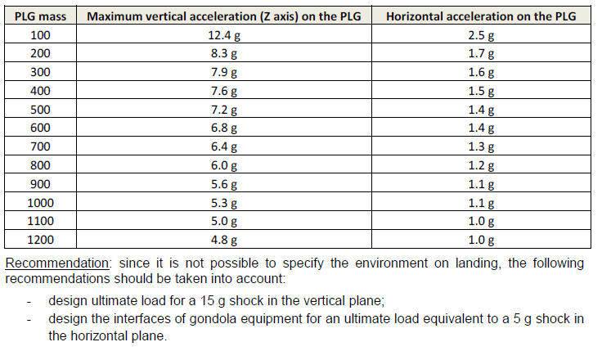

*(*3)*

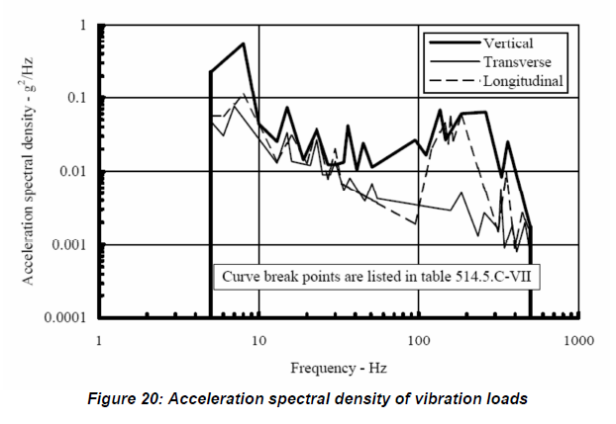

Aside from the compliance matrix shown previously, the following table is the team’s own compliance matrix for the payload:

|  |  |  |  |  |  |
| --- | --- | --- | --- | --- | --- |
| **Category** | **Requirement** | **Verification Method** | **Description** | **Compliance** | **Remarks** |
| **Experiment Structure**  **Requirements** | Payload must be contained within the Pelican case | A/T/I |  | C |  |
| Payload must weigh less than 12kg | A/T/I |  | C |  |
| Payload must be compatible with the gondola | A/T/I |  | C |  |
| Payload must survive a violent landing (up to 2 g) | A/S/T |  | PC | Drop test results showed that epoxy is not enough to hold the structure together. M2 screws will be used instead to assemble the chambers and secure to the base plate.  Compliance will be confirmed upon assembly of chamber |
| Power consumption must be less than 30Wh | A/T/I |  | C |  |
| **Electrical and Power Requirements** | Components must need less than 28V | A/T |  | C |  |
| Electrical Components must operate at low temperatures and low pressures | A/T/S |  | C | Freezer testing showed that the actuators cannot function at -25°C. Enclosures were designed to contain the actuators and heat them up to operating range.  Flight computer, environmental sensor, and H-bridge controllers are fully operational during and after the test. |
| Memory cards should be able to survive rough or water landing | S/T/I | Even if the other electrical components do not survive the rough landing, the memory cards should at least be recovered | C | microSD cards have been shown to be resilient, surviving a whole year exposed in the elements. |
| Electrical Components should survive condensation | S/T/I |  | C | Freezer test shows that the flight computer, environmental sensors, and h-bridge controllers can survive condensation and low temperatures. |
| Sampling rods must be able to capture bio aerosols | S/T/I |  | PC | Proof has been shown by a previous research and confirmed via consultation with the original author.   Ground testing still has to be executed |
| **Experimental Requirements** | Airflow through the Pelican case must be adequate during sampling | A/S/T/I |  | PC | Fan selection and Computational Fluid Dynamics modelling is in progress |
| Sampling chambers must be open at pre-set altitudes during the ascent phase of the flight | S/T/I |  | C | GPS was confirmed to get a satellite even when situated within the Pelican case. Contingencies are in place wherein GPS coordinates from the avionics gondola will be obtained in case the on-board GPS fails.  If both systems fail, the flight software can extrapolate altitude based on previous recordings of altitude and ascent speed. |
| Sampling chambers must not be open at any other non-designated altitudes | S/T/I |  | C | GPS was confirmed to get a satellite even when situated within the Pelican case. Contingencies are in place wherein GPS coordinates from the avionics gondola will be obtained in case the on-board GPS fails.  If both systems fail, the flight software can extrapolate altitude based on previous recordings of altitude and ascent speed. |
| Sampling chambers must be closed during the descent phase of the flight | S/T/I |  | C | GPS was confirmed to get a satellite even when situated within the Pelican case. Contingencies are in place wherein GPS coordinates from the avionics gondola will be obtained in case the on-board GPS fails.  If both systems fail, the flight software can extrapolate altitude based on previous recordings of altitude and ascent speed. |
| The opening and the closing of the chambers must be confirmed and recorded | S/T/I | The experiment hinges upon the opening and closing of the chambers so they must be confirmed and recorded | C | Sensors and camera on board will record actuator movement and position |
| Sampling rods must not be contaminated before the flight | S/T/I | Sampling rods must be pure before loading them onto the chambers and pelican case during assembly and integration | C | Pre-flight procedures have been laid out to ensure contamination is avoided. |
| Sampling rods must not be contaminated during the flight | S/T/I | The doors must be sealed airtight, and any air coming in when the chamber is not active must be filtered of bioaerosols | C | Redesign and consultation with machine shop personnel confirms that current design is an effective airtight seal.  The pressure equalization valve is filtered with a .22 micron Syringe filter |
| Sampling rods must not be contaminated after the flight | S/T/I | After the flight and the chambers have been recovered, the sampling rods must not be contaminated until post flight experiments begin. | C | Post-flight procedures have been laid out to ensure contamination is avoided. |
| Sampling chamber must be able to equalize pressure with the environment | S/T/I | Since the doors would be sealed air tight, pressure equalization between the chamber and the environment must be realized | C | The current design allows for the pressure equalization through the Luer Lock and syringe filter |
| One control chamber must remain closed all throughout the flight | S/T/I | This control chamber would provide a context for the rest of the sapling chambers | C | No actuator will be attached to this control chamber and thus will remain closed |
| A control chamber on the ground not included in the flight must be open for the duration of the flight | S/T/I | This control chamber would provide context as well for post flight analysis if in case the rods are contaminated on site | C | A sampling chamber would be left open on the ground before flight begins |
| A control chamber must remain within a clean room for a baseline | S/T/I | The clean room control chamber would establish the absolute baseline for the contamination state of the sampling rods even before the flight | C | A sampling chamber would be left open in the clean room at Western before the campaign begins |
|  |  |  |  |  |

|  |
| --- |
| **Compliance Statement References** |

COMPLIANCE STATEMENT REFERENCES

MECHANICAL ANALYSIS

See Section 4.4.

Contants

Reference CSA-STRATOS-RPT-0101

Fasteners

Ref : ECSS-E-HB-32-23A, 16 April 2010, Eq. 5.4.3, p.42



Aluminum



Project



STRAPS

Reference CSA-STRATOS-RPT-0101

The breaking strength (room temperature) of a buckled strap is described in CNES's document BSO-CR-NCU-8678-CN recalled below:





L-BRACKETS CALCULATION

Reference CSA-STRATOS-RPT-0101



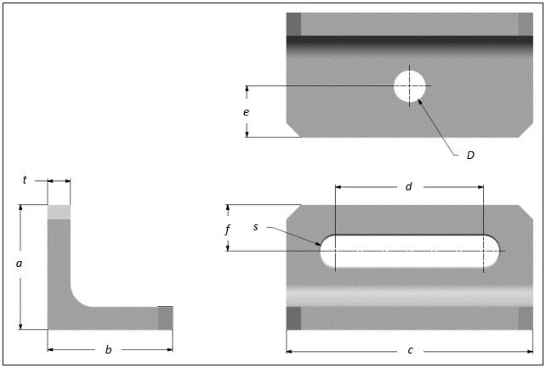

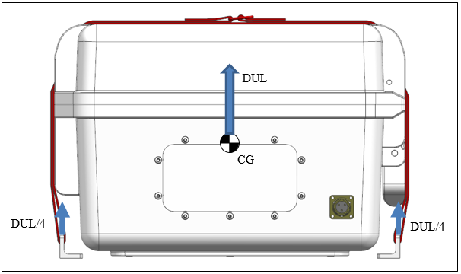

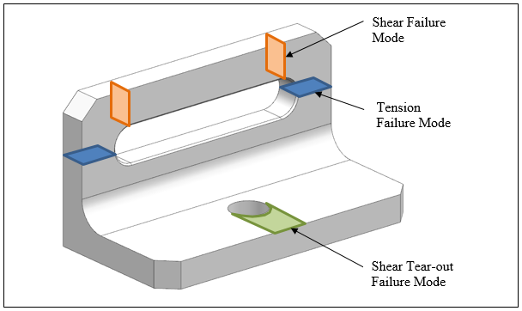

A) Bolt Bearing and Shear Tear-out Verification

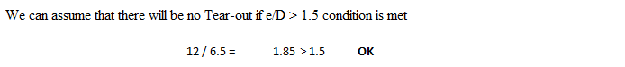

B) Bracket Failure Mode in Tension and Shear



C) Failure verification using strap tensile limit of 4600 N



M6 BOLT FAILURE

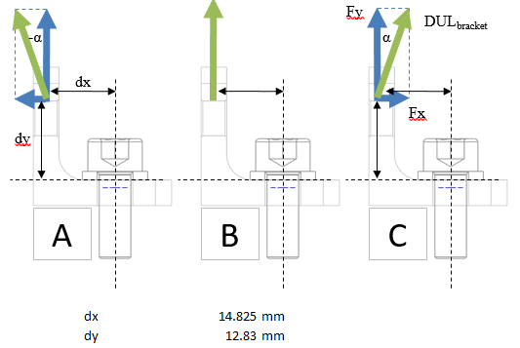

Since the strap orientation can slightly vary, here is a verification of the bending loads on the bolt for different strap angles (-45°to 45°)





**Conclusion**

The above bolt and bracket analysis represent a really conservative case since the vertical acceleration (combined with a lateral acceleration) is considered generating a pulling force in the straps and fixation elements. The actual real case of a separation and landing will generate a downward acceleration (still combined with a lateral acceleration) which will more or less compress the payload elements (enclosure) against the gondola panel. However, the gondola inclination, during these events, is hard to predict so this is why we use a conservative calculation.

The bolt survives all load conditions (tension, shear and bending) independently of the strap orientation (scenario A, B and C). We can notice that a strap angle of -45deg generate less bending since the force is aligned with the bolt and therefore creates no moment.

TESTS

**Freezer Test (Ongoing):**

We placed the actuator, Arduino, and prototype sample chamber into a freezer that can reach -25°C for approximately 6 hours. This test showed that the actuator could not operate at -25°C temperatures and requires more heating in order to keep it within an operational range. We have added additional active heating solutions in order to maintain a temperature of at least -10°C and are conducting further tests with alternative actuator to verify that it will continue to operate during the entire duration of the flight. The Arduino was operational throughout the test and we are confident in its ability to perform in the upcoming dry run in July.

**Drop Impact Test (Late June):**

Drop tests showed that the chamber and doors cannot be assembled using epoxy alone. For this reason, the chambers, doors, and rod holders will be milled from a solid aluminum block. As well, M2 screws will be used to secure the actuator to the chamber, the rod holder to the door, and the chamber to the baseplate.

After payload assembly, the drop test will be repeated to ensure that the solution put forward is adequate enough.

**Vibration test**: At the same time, we will manually vibrate the payload to determine how much disturbance is required to dislodge any equipment or electrical connections. This will ensure that all critical components are secured adequately.

**Biological Analysis Dry-Run (July):**

To practice the biological analysis and to assess any logistical problems that might arise a week or so will be dedicated to collecting a dummy, ground sample from the Western campus and analyzing it as if it had been obtained from one of the sample chambers of the payload. The dry run includes a basic characterization procedure of the samples we collected, and is a scaled down version of the entire procedure in order to meet the time constraints. The duration of the DNA extraction procedure is expensive and takes several weeks, so it became impractical to perform a full dry run. The full DNA extraction procedure has been drafted, reviewed and approved by aerobioilogy subject matter experts. This has helped us to constrain our target bioaerosol type down from a general collection of bioaerosols of all sizes to bacteria in the 0.2–5 *µ*m range.

**Airflow Test (Ongoing):**

The design of the payload has been incorporated into an airflow simulation software that will allow us to determine what airflow must be induced within the chamber in order to achieve the impact levels described in Bryan et al. (2014) for particles in the 0.2–5 *µ*m range. This is to ensure that the rotorods in our sampling chambers will be exposed to enough air that they actually are able to pick up bioaerosols.

**Payload Preparation Rehearsal (July):**

To rehearse our roles at the launch site we will have two-three rehearsals where the payload is prepared for flight. This includes preparation of the rotorods, assembly of the chambers, and any and all pre-flight checks. We do this to ensure there are no surprises when assembling at the launch site.

**Flight Rehearsal (July):**

With the payload mostly complete, we will simulate the flight with a program that will feed GPS data to the flight computer as if the payload is flying. We will then observe that the actuators open and close the chambers at their target altitudes, and all close on the descent phase. We will also verify that all the logging and camera recordings are stored as expected.

|  |
| --- |
| **Recovery Procedure** |

RECOVERY PROCEDURE

|  |
| --- |
| 1. Payload Name |
| CPSX-HAB | Bioaerosol Sampling Procedure |

|  |
| --- |
| 1. Provided Materials |
| * Cooler * Dry ice / ice depending on availability * Screwdriver * Individual chamber bags / containers * Recovery documentation note page * Sealable bag for S.D. cards |

|  |
| --- |
| 1. Equipment List |
| The only equipment that needs to be turned off is the flight computer. A switch will be installed to turn off the electronics.    Since the payload is powered by a 28V unregulated line, a 12V step down DC converter will be installed to power all the electronics. A switch will also be installed between the VIN of the converter and the positive line of the source to ensure that everything can be turned on and off at will. The switch will be clearly labelled on the payload. |

|  |
| --- |
| 1. Location on Gondola |
| [CPSX-HAB | Bioaerosol Sampling pictured here in brown] |

|  |  |  |  |  |  |
| --- | --- | --- | --- | --- | --- |
| 1. Recovery Activities | | | | | |
| Recovery Date : | |  |  |  | |
| Year | Month | Day | |
| Step | Description | | | | Completion |
|  | a) Remove the pelican case from the gondola  b) Visually confirm whether the vents on the side of the case have been breached and note their condition. Regardless of the condition of the vents, proceed with the following.  c) Open the pelican case and visually confirm that no mud or water has breached the interior of the pelican case. Small amounts of mud are acceptable. Note any dirt or damage on the recovery documentation page provided.  d) Confirm the sampling chambers are closed and secured to the pelican case. Note on the provided recovery documentation sheet.  e) Remove each chamber using the screw driver provided and place and seal in the provided containers.  f) Write the label seen on the top of the chamber on the container you store the chamber in.  g) Immediately place the contained chambers in the provided cooler with dry ice.  h) Deliver the cooler to the provided address as soon as possible | | | | ___________  Time  ___________  Initials |
|  | a) Open the electronics housing once the pelican case has been opened.  b) Remove the S.D. card and store in the provided sealable bag.  c) Close the pelican case and deliver both the pelican case and the S.D. card along with the cooler as soon as possible. | | | | ___________  Time  ___________  Initials |